LAB Logbook

Lab 11
Week 11
SID:89 SO DIVIDED BY 2 WE GET 44.5 I TOOK NEAREST VALUE AS 45
Time for epoch 1
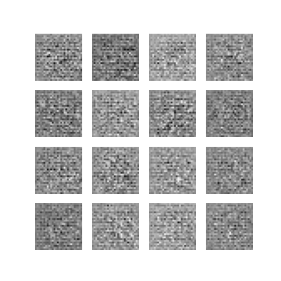
Time for epoch 45
